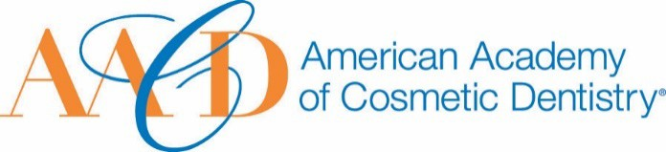
AMERICAN ACADEMY OF COSMETIC DENTISTRY

402 W. Wilson Street Madison, WI 53703
1-800-543-9220
1-608-222-8583

Nomination Submission

Email completed form to AACD: awards@aacd.com
The deadline for submissions is Friday, January 10th, 2020, at 5:00p.m. CT.

AACD Affiliate Spirit Award

This award is given to one noteworthy AACD Affiliate Member that is suggested by an AACD Affiliate President or AACD Affiliate member who has contributed significantly to his/her Affiliate and meets the following criteria:

- AACD member in good standing
- A strong leader, whether a long-time member or young, energetic go-getter
- Is passionate and a true advocate for the Affiliate
- Devotes his/her time and energy to make the Affiliate successful

Picture of Nominee (optional)
I, would like to nominate... Full Name: Date of Submission: Your Phone Number: Your Email Address:

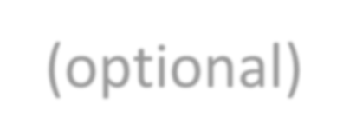How long have you known of been associated with the nominee?

On the following page we ask that you please provide a detailed answer between 500 - 1000 words incorporating responses to the following questions:

How did you become aware of the nominee's qualifications?
  - Describe a specific instance where the nominee's spirit was made apparent to you.

THANK YOU FOR YOUR SUBMISSION!
Please save this PDF/Microsoft Word file and email it to our Awards Committee for review at:
awards@aacd.com
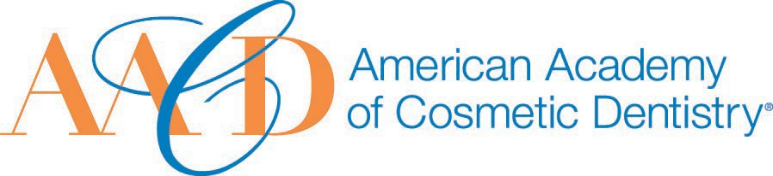
The deadline for submissions is Friday, January 10th, 2020, at 5:00p.m. CT.

