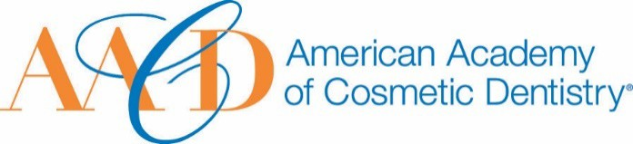
AMERICAN ACADEMY OF COSMETIC DENTISTRY

402 W. Wilson Street Madison, WI 53703
1-800-543-9220
1-608-222-8583

Nomination Submission

Email completed form to AACD: awards@aacd.com
The deadline for submissions is January 11th 2019 at 5:00p.m. CT.

AACD Affiliate Leader Award
This award is given to one noteworthy AACD Affiliate Member who is President or Vice President of his/her Affiliate who has contributed significantly to the growth and leadership of his/her Affiliate and who is an AACD member in good standing.

Nominations for the Affiliate Leader Award can be submitted by AACD Affiliate members or by the Affiliate Relations Committee.

Full Name: Date of Submission: Your Phone Number:

Picture of Nominee (optional)
Your Email Address:

Name of Nominee:

How long have you known of been associated with the nominee?

How did you become aware of the nominee's qualifications?

Please describe a specific instance where the nominee’s strengths were made apparent to you:

Why do you feel this nominee exemplifies the spirit

THANK YOU FOR YOUR SUBMISSION!
Please save this PDF/Microsoft Word file and email it to our Awards Committee for review at:
awards@aacd.com
The deadline for submissions is January 11th 2019 at 5:00p.m. CT.
