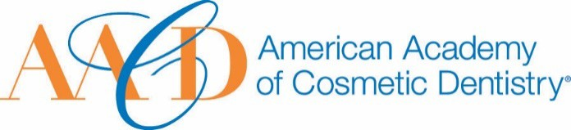
AMERICAN ACADEMY OF COSMETIC DENTISTRY
402 W. Wilson Street Madison, WI 53703
1-800-543-9220
1-608-222-8583

Email completed form to AACD: awards@aacd.com
The deadline for submissions is January 11th 2019 at 5:00p.m. CT.
Hall of Fame Award
This award is given to an AACD Member, living or deceased, whose contributions to the field of cosmetic dentistry and service to the Academy have been significant, substantial, and long-standing.
Nomination Submission

Full Name: Date of Submission: Your Phone Number:
Picture of Nominee (optional)
Your Email Address:

Name of Nominee:

How long have you known or been associated with the nominee?

How did you become aware of the nominees qualifications?:

Please describe a specific instance where the nominee’s strengths were made apparent to you:

- Describe the contribution this nominee has made to the profession and how they were involved with or served the AACD through leadership and/or educational initiatives. You may use images to support your answer. Please provide a detailed answer between 200-1000 words:

THANK YOU FOR YOUR SUBMISSION!
Please save this PDF/Microsoft Word file and email it to our Awards Committee for review at:
awards@aacd.com
The deadline for submissions is January 11th 2019 at 5:00p.m. CT.
