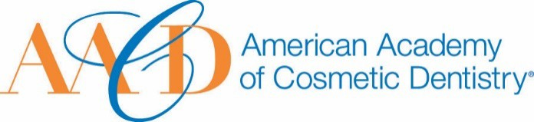
AMERICAN ACADEMY OF COSMETIC DENTISTRY
402 W. Wilson Street Madison, WI 53703
1-800-543-9220
1-608-222-8583

Email completed form to AACD: awards@aacd.com
The deadline for submissions is January 11th 2019 at 5:00p.m. CT.
Humanitarian Award
This award is given to an AACD Member who has made outstanding contributions to charitable and philanthropic causes. All types of humanitarian actions, both within and outside of the dental industry, will be considered for this award.
Nomination Submission

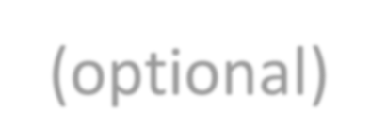Full Name: Date of Submission: Your Phone Number:
Picture of Nominee (optional)
Your Email Address:

Name of Nominee:

How long have you known or been associated with the nominee?

How did you become aware of the nominees qualifications?:

Please describe a specific instance where the nominee’s strengths were made apparent to you:

Describe the nature of the humanitarian activity.
You may use images to support your answer. Please provide a detailed answer
between 200-1000 words:

- How many people benefitted from this activity?
You may use images to support your answer. Please provide a detailed answer between 200-1000 words:

- Assess the impact it has had or will have on the beneficiaries of his/her humanitarian work. You may use images to support your answer. Please provide a detailed answer between 200-1000 words:

THANK YOU FOR YOUR SUBMISSION!
Please save this PDF/Microsoft Word file and email it to our Awards Committee for review at:
awards@aacd.com
The deadline for submissions is January 11th 2019 at 5:00p.m. CT.
