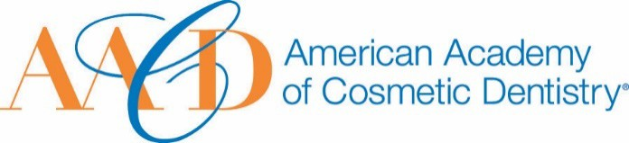
AMERICAN ACADEMY OF COSMETIC DENTISTRY
402 W. Wilson Street Madison, WI 53703
1-800-543-9220
1-608-222-8583

Email completed form to AACD: awards@aacd.com
The deadline for submissions is Friday, December 16th, 2022, at
^{11:59p.m.} ^{CT.} Humanitarian Award
This award is given to an AACD Member who has made outstanding contributions to charitable and philanthropic causes. All types of humanitarian actions, both within and outside of the dental industry, will be considered for this award.
Nomination Submission

I, nominate...
Picture of Nominee (optional)

Full Name: Date of Submission: Your Phone Number:
Your Email Address:

How long have you known or been associated with the nominee?

On the following page we ask that you please provide a detailed answer between 500 - 1000 words incorporating responses to the following questions:

- How did you become aware of the nominee's qualifications?
- Please describe a specific instance where the nominee's strengths were made apparent to you.

- Describe the nature of the humanitarian activity and how many people benefited from this activity?

- Assess the impact it has had or will have on the beneficiaries of his/her humanitarian work.

THANK YOU FOR YOUR SUBMISSION!
Please save this PDF/Microsoft Word file and email it to our Awards Committee for review at:
awards@aacd.com
The deadline for submissions is Friday, December 16th, 2022, at 11:59p.m. CT.
