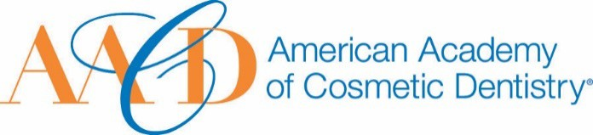
AMERICAN ACADEMY OF COSMETIC DENTISTRY
402 W. Wilson Street Madison, WI 53703
1-800-543-9220
1-608-222-8583

Email completed form to AACD: awards@aacd.com
The deadline for submissions is January 11th 2019 at 5:00p.m. CT.
Lifetime Achievement Award

This award is given to an outstanding professional within the industry who has made outstanding contributions over his/her lifetime to the field of cosmetic dentistry.
Note: if the nominee is not an AACD Member, they must've spoken at a previous Scientific Session.
Nomination Submission

Full Name: Date of Submission: Your Phone Number:
Picture of Nominee (optional)
Your Email Address:

Name of Nominee:

How long have you known or been associated with the nominee?

How did you become aware of the nominees qualifications?:

Please describe a specific instance where the nominee’s strengths were made apparent to you:

Describe the contribution this nominee has made to the profession, particularly
in the area of cosmetic dentistry. You may use images to support your answer. Please provide a detailed answer between 200-1000 words:

THANK YOU FOR YOUR SUBMISSION!
Please save this PDF/Microsoft Word file and email it to our Awards Committee for review at:
awards@aacd.com
The deadline for submissions is January 11th 2019 at 5:00p.m. CT.
