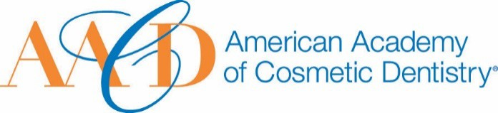
AMERICAN ACADEMY OF COSMETIC DENTISTRY
402 W. Wilson Street Madison, WI 53703
1-800-543-9220
1-608-222-8583

Email completed form to AACD: awards@aacd.com
The deadline for submissions is Friday, January 10th, 2020, at 5:00p.m. CT.
Lifetime Achievement Award

This award is given to an outstanding professional within the industry who has made outstanding contributions over his/her lifetime to the field of cosmetic dentistry.
Note: if the nominee is not an AACD Member, they must've spoken at a previous Scientific Session.

Nomination Submission

I, nominate...

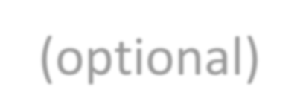Full Name: Date of Submission: Your Phone Number:
Picture of Nominee (optional)
Your Email Address:

How long have you known or been associated with the nominee? _

On the following page we ask that you please provide a detailed answer between 500 - 1000 words incorporating responses to the following questions:

How did you become aware of the nominee's qualifications?
- Please describe a specific instance where the nominee's strengths were made apparent to you.

- Describe the contribution this nominee has made to the profession particularly in the area of cosmetic dentistry.

THANK YOU FOR YOUR SUBMISSION!
Please save this PDF/Microsoft Word file and email it to our Awards Committee for review at:
awards@aacd.com
The deadline for submissions is Friday, January 10th, 2020, at 5:00p.m. CT.

