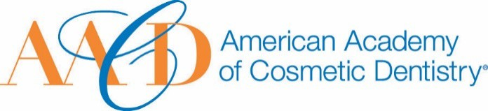
AMERICAN ACADEMY OF COSMETIC DENTISTRY
402 W. Wilson Street Madison, WI 53703
1-800-543-9220
1-608-222-8583

Email completed form to AACD: awards@aacd.com
The deadline for submissions is January 11th 2019 at 5:00p.m. CT.
Outstanding Innovation in Cosmetic Dentistry Award
This award is given to an AACD member who has had an exceptional impact on or made significant improvements to or advancements in the fields of cosmetic or restorative dentistry.
Nomination Submission

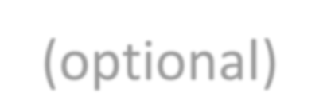Full Name: Date of Submission: Your Phone Number:
Picture of Nominee (optional)
Your Email Address:

Name of Nominee:

How long have you known or been associated with the nominee?

How did you become aware of the nominees qualifications?:

Please describe a specific instance where the nominee’s strengths were made apparent to you:

In what respect has this nominee been innovative?

You may use images to support your answer. Please provide a detailed answer
between 200-1000 words:

- What impact will this innovation have on the fields of cosmetic dentistry? You may use images to support your answer. Please provide a detailed answer between 200-1000 words:

THANK YOU FOR YOUR SUBMISSION!
Please save this PDF/Microsoft Word file and email it to our Awards Committee for review at:
awards@aacd.com
The deadline for submissions is January 11th 2019 at 5:00p.m. CT.
