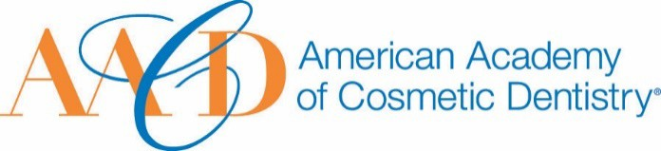
AMERICAN ACADEMY OF COSMETIC DENTISTRY
402 W. Wilson Street Madison, WI 53703
1-800-543-9220
1-608-222-8583

Email completed form to AACD: awards@aacd.com
The deadline for submissions is January 11th 2019 at 5:00p.m. CT.
Outstanding Service Award
This award is given to an AACD member who has shown outstanding service to the American Academy of Cosmetic Dentistry or via the time and effort they have devoted to serving as an ambassador for the Academy through dedicated leadership or by serving individual members of the Academy as a mentor/new member advisor.
Nomination Submission

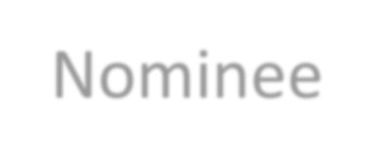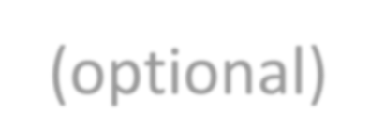Full Name: Date of Submission: Your Phone Number:

Your Email Address:

Name of Nominee:

How long have you known or been associated with the nominee?

How did you become aware of the nominees qualifications?:

Please describe a specific instance where the nominee’s strengths were made apparent to you:

- Describe the nature of the service this nominee has given to the Academy. You may use images to support your answer. Please provide a detailed answer between 200-800 words:

Assess its significance and the impact it has had on the Academy.

You may use images to support your answer. Please provide a detailed answer
between 200-800 words:

THANK YOU FOR YOUR SUBMISSION!
Please save this PDF/Microsoft Word file and email it to our Awards Committee for review at:
awards@aacd.com
The deadline for submissions is January 11th 2019 at 5:00p.m. CT.
