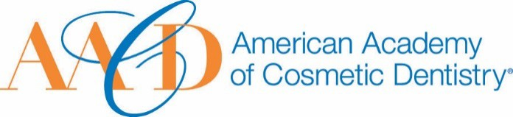
AMERICAN ACADEMY OF COSMETIC DENTISTRY
402 W. Wilson Street Madison, WI 53703
1-800-543-9220
1-608-222-8583

Email completed form to AACD: awards@aacd.com
The deadline for submissions is January 11th 2019 at 5:00p.m. CT.
Rising Star Award
This award is given to an AACD Member who shows the greatest leadership potential for the AACD or in the cosmetic dentistry industry in general (regardless of age or length of time within the profession).
Nomination Submission

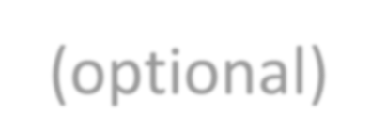Full Name: Date of Submission: Your Phone Number:
Picture of Nominee (optional)
Your Email Address:

Name of Nominee:

How long have you known or been associated with the nominee?

How did you become aware of the nominees qualifications?:

Please describe a specific instance where the nominee’s strengths were made apparent to you:

- Describe the leadership involvement this involvement this nominee has had in the Academy. You may use images to support your answer. Please provide a detailed answer between 200-1000 words:

- What contributions has the nominee made to and/or what impact has the nominee had in the Academy? You may use images to support your answer. Please
provide a detailed answer between 200-1000 words:

- What leadership qualities or what potential do you see in the nominee? You may use images to support your answer. Please provide a detailed answer between 200-1000 words:

THANK YOU FOR YOUR SUBMISSION!
Please save this PDF/Microsoft Word file and email it to our Awards Committee for review at:
awards@aacd.com
The deadline for submissions is January 11th 2019 at 5:00p.m. CT.
