
Find a Cosmetic Dentist
Join AACD • Find a Laboratory Technician |
- Consumer Studies

Can a new smile make you appear more successful and intelligent?
Previous consumer studies have proved that a beautiful smile will make you more attractive. But according to research conducted by Beall Research & Training of Chicago, a new smile will make you appear more intelligent, interesting, successful and wealthy to others as well.
Dr. Anne Beall, a social psychologist and market research professional carried out the independent study on behalf of the American Academy of Cosmetic Dentistry (AACD). Pictures of eight individuals were shown to 528 Americans, a statistically valid cross section of the population. The respondents were asked to quickly judge the eight people as to how attractive, intelligent, happy, successful in their career, friendly, interesting, kind, wealthy, popular with the opposite sex, and sensitive to other people they were.
Two sets of photos were created, with each set showing four individuals before undergoing cosmetic dentistry, and four after treatment. Half the respondents viewed set A, the other half set B. The eight subjects viewed by respondents were evenly divided by gender. Two had mild improvements through cosmetic dentistry, two had moderate improvements, and four had major improvements to their smiles, to give a wide range for respondents to view. None, however, had visibly rotten teeth, missing teeth or catastrophically bad dental health in the before shots. Respondents were not told that they were looking at dentistry, but were asked to make snap judgments rating each person for the ten characteristics, on a scale of one to ten, with “one” being “not at all,” and “ten” being “extremely.”
The results indicated that an attractive smile does have broad ranging benefits:
Characteristic Average | “Before” rating | “After” rating | Increase
Attractive | 4.6 | 5.9 | 1.3
Intelligent | 5.9 | 6.5 | .6
Happy | 6.2 | 6.8 | .4
Successful in their career | 5.8 | 6.7 | .9
Friendly | 6.3 | 6.8 | .5
Interesting | 5.4 | 6.1 | .7
Kind | 6.0 | 6.4 | .4
Wealthy | 4.9 | 5.9 | 1.0
Popular with the opposite sex | 5.0 | 6.2 | 1.2
Sensitive to other people | 5.6 | 6.1 | .5
While the change was most dramatic for Attractive, Popular with the opposite sex, Wealthy and Successful in their career, the change was statically significant in all areas.
Below are some before and after images that were used in the above study.
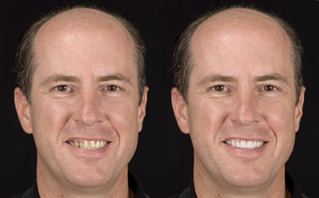


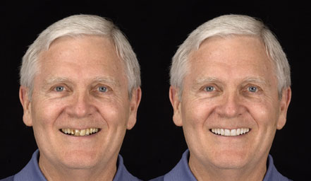
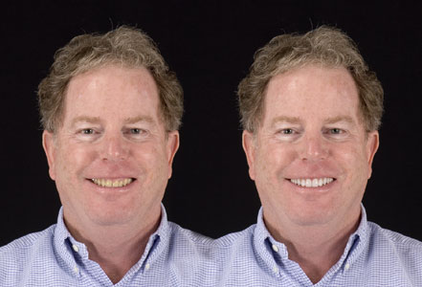
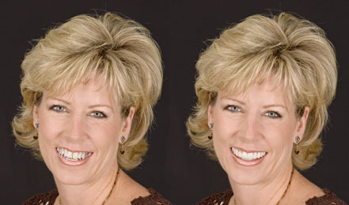
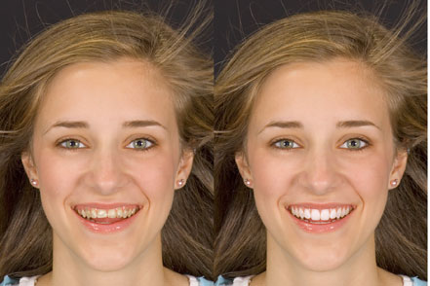
In an independent study conducted on behalf of the AACD in 2004, we discovered:
Virtually all Americans (99.7%) believe a smile is an important social asset.
96% of adults believe an attractive smile makes a person more appealing to members of the opposite sex.
Three-quarters (74%) of adults feels an unattractive smile can hurt a person's chances for career success.
When asked, "What is the first thing you notice in a person's smile?" The most common responses were:
- Straightness
- Whiteness & Color of Teeth
- Cleanliness of Teeth
- Sincerity of Smile
- Any Missing Teeth?
- Sparkle of Smile
And when asked, "What types of things do you consider make a smile unattractive?" The most common responses were:
- Discolored, Yellow, or Stained Teeth
- Missing Teeth
- Crooked Teeth
- Decaying Teeth & Cavities
- Gaps & Spaces in Teeth
- Dirty Teeth
And finally, when respondents were asked, "What would you most like to improve about your smile?" The most common response was:
- Whiter & Brighter Teeth

